**Lab-10**

Name: - Divyesh Chotaliya

Roll No.: - IT021

**Aim: - Create the Sign In, Sign Up and Update Application**

Code:-

1. **Signup.aspx**

<%@ Page Language="C#" AutoEventWireup="true" CodeBehind="Signup.aspx.cs" Inherits="Lab10.Signup" %>

<!DOCTYPE html>

<html xmlns="http://www.w3.org/1999/xhtml">

<head runat="server">

<title></title>

</head>

<body>

<form id="form1" runat="server">

<div>

<asp:Label ID="Label1" runat="server" Style="z-index: 1; left: 10px; top: 15px; position: absolute" Text="UserName"></asp:Label>

<asp:TextBox ID="TextBox1" runat="server" Style="z-index: 1; left: 97px; top: 16px; position: absolute"></asp:TextBox>

<asp:TextBox ID="TextBox2" runat="server" Style="z-index: 1; left: 96px; top: 55px; position: absolute"></asp:TextBox>

<asp:TextBox ID="TextBox3" runat="server" Style="z-index: 1; left: 144px; top: 93px; position: absolute"></asp:TextBox>

<asp:TextBox ID="TextBox4" runat="server" Style="z-index: 1; left: 141px; top: 134px; position: absolute"></asp:TextBox>

<asp:Label ID="Label2" runat="server" Style="z-index: 1; left: 15px; top: 51px; position: absolute" Text="Password"></asp:Label>

</div>

<asp:Label ID="Label3" runat="server" Style="z-index: 1; left: 14px; top: 92px; position: absolute"

Text="Conform Password"></asp:Label>

<asp:Label ID="Label4" runat="server" Style="z-index: 1; left: 19px; top: 132px; position: absolute"

Text="City"></asp:Label>

<asp:Button ID="Button1" runat="server" OnClick="Button1_Click" Style="z-index: 1; left: 71px; top: 193px; position: absolute"

Text="SignUp" />

<asp:CompareValidator ID="CompareValidator1" runat="server" ControlToCompare="TextBox2"

ControlToValidate="TextBox3" ErrorMessage="Not Matched" Style="z-index: 1; left: 290px; top: 96px; position: absolute"></asp:CompareValidator>

</form>

</body>

</html>

1. **Signup.aspx.cs**

using System;

using System.Collections.Generic;

using System.Configuration;

using System.Data.SqlClient;

using System.Linq;

using System.Web;

using System.Web.UI;

using System.Web.UI.WebControls;

namespace Lab10

{

public partial class Signup : System.Web.UI.Page

{

protected void Page_Load(object sender, EventArgs e)

{

}

protected void Button1_Click(object sender, EventArgs e)

{

SqlConnection cn = new SqlConnection();

cn.ConnectionString = "Data Source=(LocalDB)\\MSSQLLocalDB;AttachDbFilename=E:\\SEM-VII\\WT\\Lab10\\App_Data\\Database1.mdf;Integrated Security=True";

cn.Open();

SqlCommand cm = new SqlCommand("insert into [UserData] values('" + TextBox1.Text + "','" + TextBox2.Text + "','" + TextBox4.Text + "')", cn);

int i = cm.ExecuteNonQuery();

cn.Close();

if (i == 1) { Response.Redirect("Login.aspx"); }

else { Response.Write("Error"); }

}

}

}

1. **Login.aspx**

<%@ Page Language="C#" AutoEventWireup="true" CodeBehind="Login.aspx.cs" Inherits="Lab10.Login" %>

<!DOCTYPE html>

<html xmlns="http://www.w3.org/1999/xhtml">

<head runat="server">

<title></title>

</head>

<body>

<form id="form1" runat="server">

<div>

<asp:Label ID="Label1" runat="server" Style="z-index: 1; left: 8px; top: 43px; position: absolute"

Text="UserName"></asp:Label>

<asp:Label ID="Label2" runat="server" Style="z-index: 1; left: 11px; top: 74px; position: absolute"

Text="Password"></asp:Label>

<asp:TextBox ID="TextBox1" runat="server" Style="z-index: 1; left: 101px; top: 39px; position: absolute"></asp:TextBox>

<asp:TextBox ID="TextBox2" runat="server" Style="z-index: 1; left: 99px; top: 74px; position: absolute"></asp:TextBox>

</div>

<asp:Button ID="Button1" runat="server" OnClick="Button1_Click" Style="z-index: 1; left: 54px; top: 118px; position: absolute" Text="Login" />

</form>

</body>

</html>

1. **Login.aspx.cs**

using System;

using System.Collections.Generic;

using System.Data;

using System.Data.SqlClient;

using System.Linq;

using System.Web;

using System.Web.UI;

using System.Web.UI.WebControls;

namespace Lab10

{

public partial class Login : System.Web.UI.Page

{

protected void Page_Load(object sender, EventArgs e)

{

}

protected void Button1_Click(object sender, EventArgs e)

{

SqlConnection cn = new SqlConnection();

cn.ConnectionString = "Data Source=(LocalDB)\\MSSQLLocalDB;AttachDbFilename=E:\\SEM-VII\\WT\\Lab10\\App_Data\\Database1.mdf;Integrated Security=True";

cn.Open();

SqlCommand cm = new SqlCommand("select Password from [UserData] where ( UserId='" + TextBox1.Text + "')", cn);

SqlDataAdapter da = new SqlDataAdapter(cm);

DataTable ds = new DataTable("T1");

int i = cm.ExecuteNonQuery();

da.Fill(ds);

//da.Fill(ds, "T1");

cn.Close();

//Response.Write(ds.Rows[0][0].ToString());

if (ds.Rows[0][0].ToString() == TextBox2.Text)

{

Session["id"] = TextBox1.Text;

Response.Redirect("Profile.aspx");

}

else { Response.Write("Check Password or UserName"); }

}

}

}

1. **Profile.aspx**

<%@ Page Language="C#" AutoEventWireup="true" CodeBehind="Profile.aspx.cs" Inherits="Lab10.Profile" %>

<!DOCTYPE html>

<html xmlns="http://www.w3.org/1999/xhtml">

<head runat="server">

<title></title>

</head>

<body>

<form id="form1" runat="server">

<div>

<asp:GridView ID="GridView1" runat="server" Style="z-index: 1; left: 10px; top: 34px; position: absolute; height: 133px; width: 187px" AutoGenerateColumns="False" DataKeyNames="UserId" DataSourceID="SqlDataSource1">

<Columns>

<asp:CommandField ShowDeleteButton="True" ShowEditButton="True" ShowSelectButton="True" />

<asp:BoundField DataField="UserId" HeaderText="UserId" ReadOnly="True" SortExpression="UserId" />

<asp:BoundField DataField="Password" HeaderText="Password" SortExpression="Password" />

<asp:BoundField DataField="City" HeaderText="City" SortExpression="City" />

</Columns>

</asp:GridView>

<asp:SqlDataSource ID="SqlDataSource1" runat="server" ConflictDetection="CompareAllValues" ConnectionString="<%$ ConnectionStrings:ConnectionString %>" DeleteCommand="DELETE FROM [UserData] WHERE [UserId] = @original_UserId AND [Password] = @original_Password AND [City] = @original_City" InsertCommand="INSERT INTO [UserData] ([UserId], [Password], [City]) VALUES (@UserId, @Password, @City)" OldValuesParameterFormatString="original_{0}" SelectCommand="SELECT * FROM [UserData] WHERE ([UserId] = @UserId)" UpdateCommand="UPDATE [UserData] SET [Password] = @Password, [City] = @City WHERE [UserId] = @original_UserId AND [Password] = @original_Password AND [City] = @original_City">

<DeleteParameters>

<asp:Parameter Name="original_UserId" Type="String" />

<asp:Parameter Name="original_Password" Type="String" />

<asp:Parameter Name="original_City" Type="String" />

</DeleteParameters>

<InsertParameters>

<asp:Parameter Name="UserId" Type="String" />

<asp:Parameter Name="Password" Type="String" />

<asp:Parameter Name="City" Type="String" />

</InsertParameters>

<SelectParameters>

<asp:SessionParameter Name="UserId" SessionField="id" Type="String" />

</SelectParameters>

<UpdateParameters>

<asp:Parameter Name="Password" Type="String" />

<asp:Parameter Name="City" Type="String" />

<asp:Parameter Name="original_UserId" Type="String" />

<asp:Parameter Name="original_Password" Type="String" />

<asp:Parameter Name="original_City" Type="String" />

</UpdateParameters>

</asp:SqlDataSource>

</div>

</form>

</body>

</html>

1. **Profile.aspx.cs**

using System;

using System.Collections.Generic;

using System.Data;

using System.Data.SqlClient;

using System.Linq;

using System.Web;

using System.Web.UI;

using System.Web.UI.WebControls;

namespace Lab10

{

public partial class Profile : System.Web.UI.Page

{

protected void Page_Load(object sender, EventArgs e)

{

String s = Session["id"].ToString();

//Response.Write(s.ToString());

SqlConnection cn = new SqlConnection();

cn.ConnectionString = "Data Source=(LocalDB)\\MSSQLLocalDB;AttachDbFilename=E:\\SEM-VII\\WT\\Lab10\\App_Data\\Database1.mdf;Integrated Security=True";

cn.Open();

SqlCommand cm = new SqlCommand("select * from [UserData] where UserId='" + s.ToString() +"'", cn);

SqlDataAdapter da = new SqlDataAdapter(cm);

DataTable ds = new DataTable();

cm.ExecuteNonQuery();

da.Fill(ds);

cn.Close();

}

}

}

**Output: -**

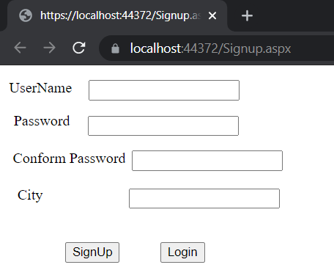

**Fig. Simple GUI**

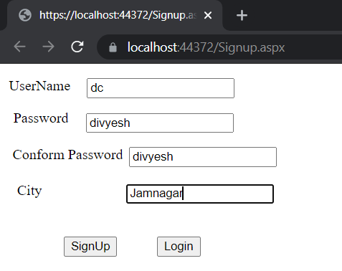

**Fig. Signup**

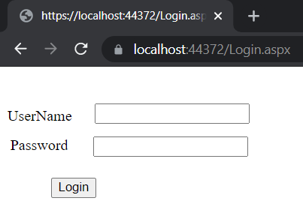

**Fig. Login Page**

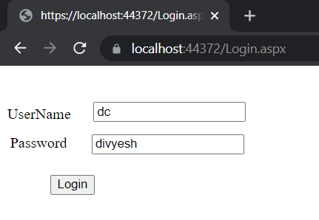

**Fig. Login Page**

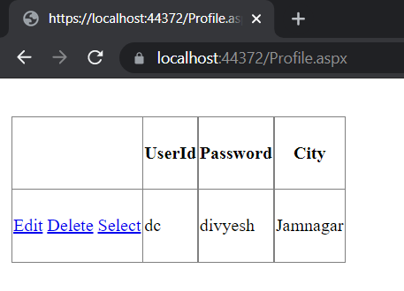

**Fig. Data**